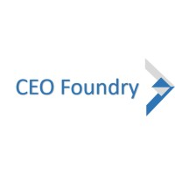



**DEVOPS COURSE CONTENT V4.0**

**Overview of AWS Cloud Services**

* Introduction
* Public vs. Private Cloud Platforms
* Infrastructure as a Service (IAAS)
* Platform as a Service (PAAS)
* 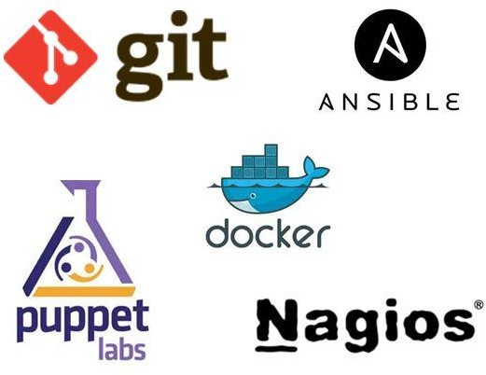Global Infrastructure

# Basics of Virtualization

•

* Introduction
* What is Virtualization
* Server Virtualization
* Desktop Virtualization
* Application Virtualization

# Basics of Networking

* Network and Host
* IPv4 and IPv6
* Classes in IPv4
* IP addressing,
* Deriving Network and Host
* Subnetting/Subnet Mask
* Private IP addresses series
* NAT addressing/NAT Gateway

•

# Basics of Linux

* Why LinuxDifferent OS of Linux

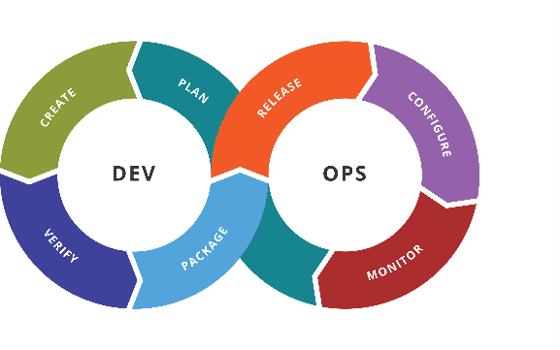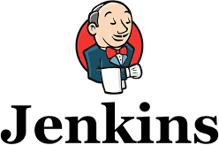

* Basic Linux commands
  + Understanding of Linux Commands

# AWS Identity Access Management (IAM)

* + Basics of IAM
  + Groups, Users, Roles, Policies, MFA
  + How to use IAM
  + Active Directory Federation
  + Web Identity Federation
  + IAM Summary

# AWS-Virtual Private Cloud(VPC)

* + What is VPC, and Why VPC is required
  + Using Default VPC
  + Launching VPC using VPC Wizard
  + Designing Custom VPC Part 1
  + Designing Custom VPC Part 2
  + Concepts about Network Address Translation (NAT)
  + Create your own NAT Instance
  + Network Access Control Lists (ACLs)
  + What is Bastion, and uses of Bastion
  + Security - Shared Responsibility

# AWS-EC2

* + What is Elastic Cloud Compute (EC2) service?
  + EBS Volumes
  + EBS Volumes Vs Instance Volume
  + Security Groups
  + Snapshots
  + AMI
  + Launch an EC2 instance with/without IAM roles
  + Windows and Linux based AMI
  + Elastic Load Balancers (ELB)
  + Auto Scaling Groups Lab

# AWS-Route53

* + What is DNS and Route53
  + Understanding DNS
  + What are different Route53 Policies

### CEO Foundry Inc.

**DevOps-Version Control-GIT**

* + - What is Version Control System?
    - Git
    - GITHUB
    - GITHUB Desktop
    - Installation
    - Configuration
    - Basic Commands
    - Branches
    - Repositories

# DevOps-Build Management- MAVEN

* + - Automated Build Process
    - Maven
    - Introduction
    - Maven Structure
    - Maven Dependencies
    - Maven Repositories
    - Maven Plugins
    - Integrated Maven Build

# DevOps-Continuous Integration -Jenkins

* + - What is Jenkins
    - Installation
    - Configuring Jenkins
    - What is node
    - Configuring node
    - Setting up a node
    - Jobs/Plugins
    - Creating Application Builds
    - Cloning the sample Project
    - Creating the Jenkins job and Configuring a Git Repo
    - Compiling in Jenkins
    - Browsing the workspace in Jenkins
    - App Packaging in Jenkins
    - Cleaning up past build

# DevOps-AWS Code Deploy and Code Pipeline

* + - Introduction to AWS Code Deploy
    - Components to AWS Code Deploy
    - AppSpec File Configuration
    - Deployment Using CodeDeploy
    - What is CodePipeline
    - Use cases of CodePipeline
    - Continuous Delivery using CodePipeLine

# DevOps-Provisioning Management Tool- VAGRANT

* + - Introduction
    - What is Vagrant?
    - Setting up Vagrant
    - Virtual Box Installation
    - Vagrant Installation
    - Vagrant without Virtual Box
    - Using Vagrant/Vagrant Machine
    - Vagrant Files
    - Boxes
    - Running Vagrant Machines
    - SSH to Vagrant Machine
    - Vagrant Boxes
    - Basic Box Management
    - Creating Boxes from existing environment

# DevOps-Provisioning Management Tool- TERRAFORM

* + - Introduction to Terraform
    - Use Cases
    - Terraform Vs Chef Vs Puppet
    - Install Terraform
    - Using Terraform
    - Launching infra using Terraform
    - Creating and Destroying Infra

# DevOps-Configuration Management Tool-Chef

* + - What is Chef?
    - Chef Server
    - Chef Workstation
    - Chef-Repo
    - Chef-Client
    - Server and Nodes
    - What is Cookbook
    - What is Knife?
    - Roles
    - Creating A web server Role
    - Creating Db Server Role
    - Creating a Base Role
    - Extending Chef
    - Knife plugins
    - Deploying Nodes in Production
    - Unattended Node Bootstrapping
    - Adding Local Chef-Repo to Github
    - Data-Bags

# DevOps-Configuration Management Tool-ANSIBLE

* + - Introduction to Ansible
    - Installing Ensile
    - Testing with First Ansible
    - Ansible Configuration Basics
    - Working with python based systems
    - Plays & Playbooks’ basics
    - Basic Play book
    - Advance Playbook usage
    - Roles
    - Introduction to Roles
    - Role Basics
    - Creating Role
    - Ansible Galaxy

# DevOps-Containerization- DOCKER

* + - What is Docker
    - Installing Docker on Windows, Linux
    - Docker Pull,Build,Run
    - Working with images
    - Container Life cycle
    - Dockerfile
    - Pushing App to GitHub
    - Configuring Test Builds
    - Performing test Builds
    - Pushing App to Production

# DevOps-Monitoring Tools

* + Nagios
  + Installation of Nagios
  + Configuring Nagios
  + Monitoring with Nagios
  + Triggering Alerts

# DevOps-Elasticsearch + logstash + Kibana

* + Installation of ELK stack
  + Configuring the ELK Stack
  + Monitoring

# AWS Lambda

* + Introduction to AWS Lambda
  + Benefits for using AWS Lambda
  + Lambda Functions
  + Lambda Triggers

# Serverless Computing with AWS Lambda

* + Introduction to Serverless Computing
  + Serverless with AWS Lambda
  + Real Time applications with AWS Lambda
  + How to trigger Lambda with S3 Bucket?

# AWS Certification Path

* + Why AWS Certification
  + Solution Architect Roadmap
  + Developer Certification Road map
  + SysOps Certification Roadmap